Bailey, Taylor 04/10/18 18SP_F2 IST190 LINUX Essentials (W02)

Lab6

Lab6-11.4-5

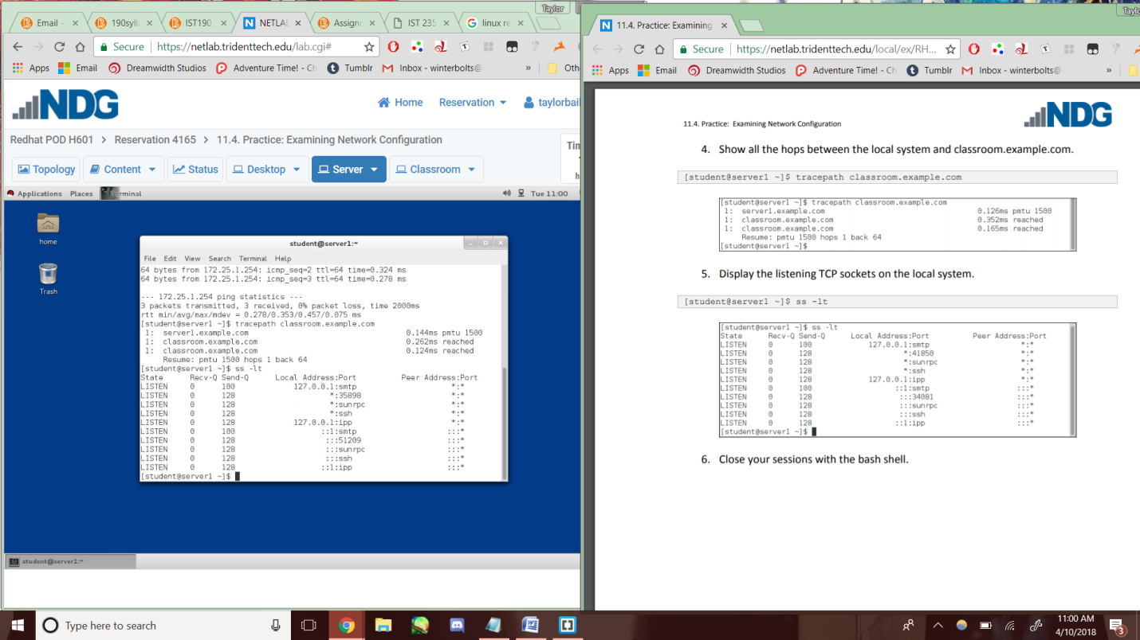

Lab6-11.6-7

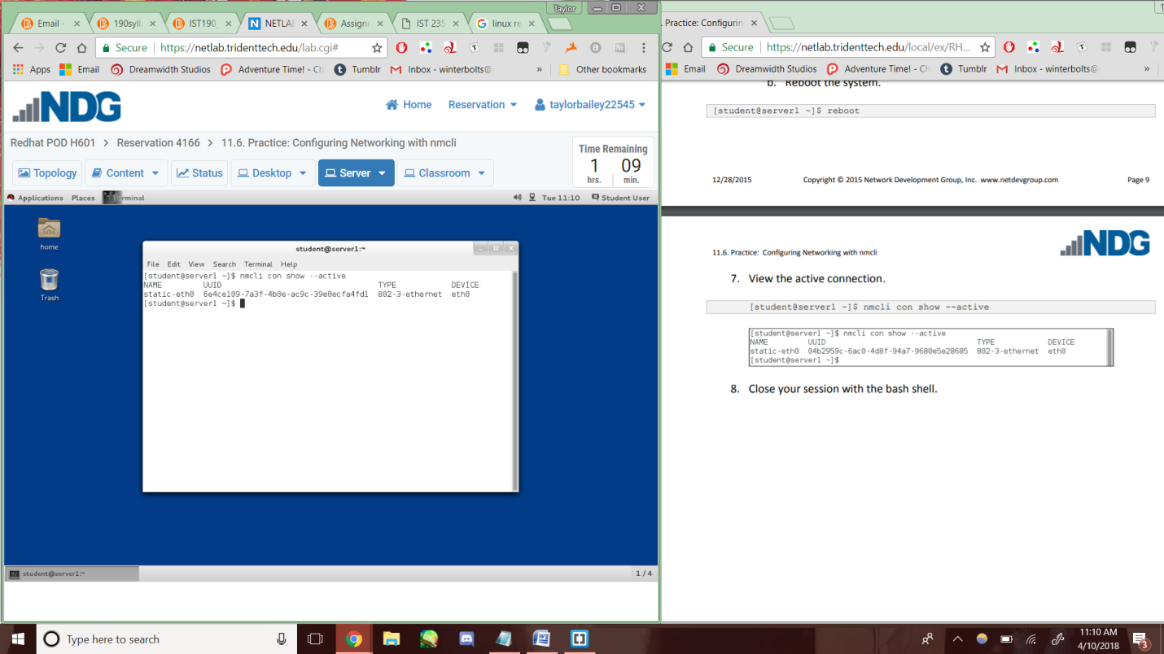

Lab6-11.8-4d

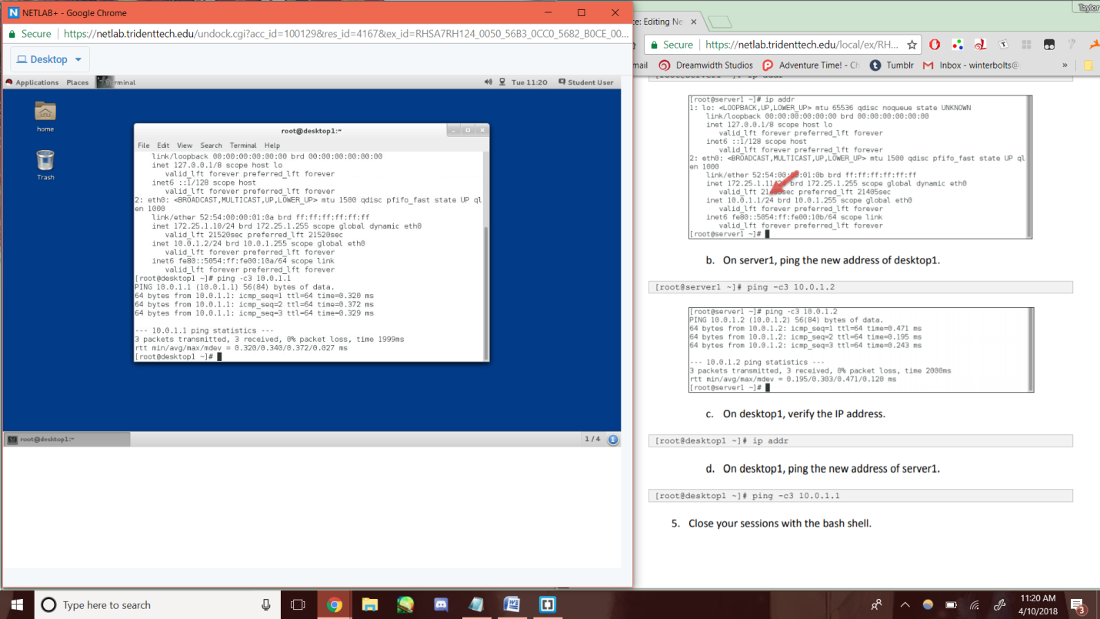

Lab6-11.10-4d

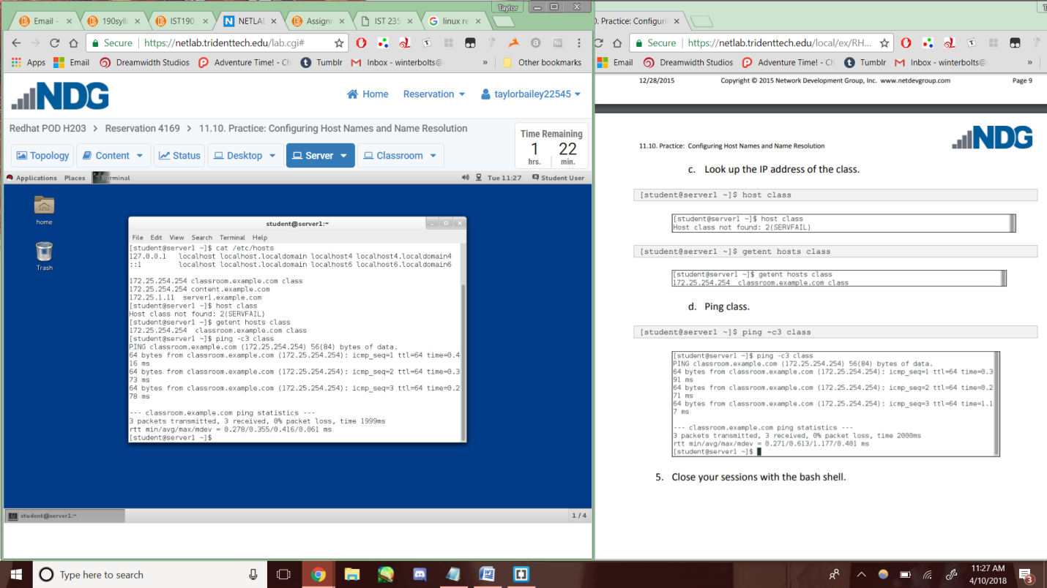

Lab6-11.11-5

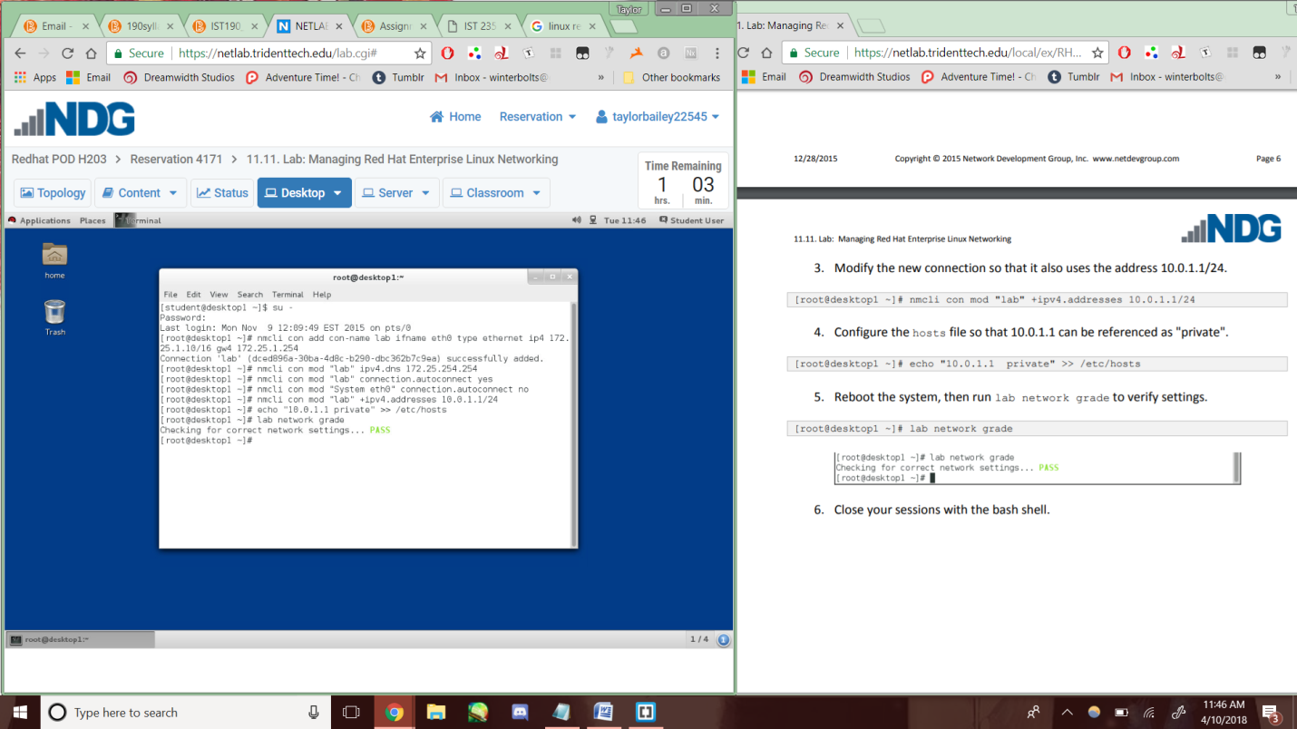

Lab6-12.2-3d

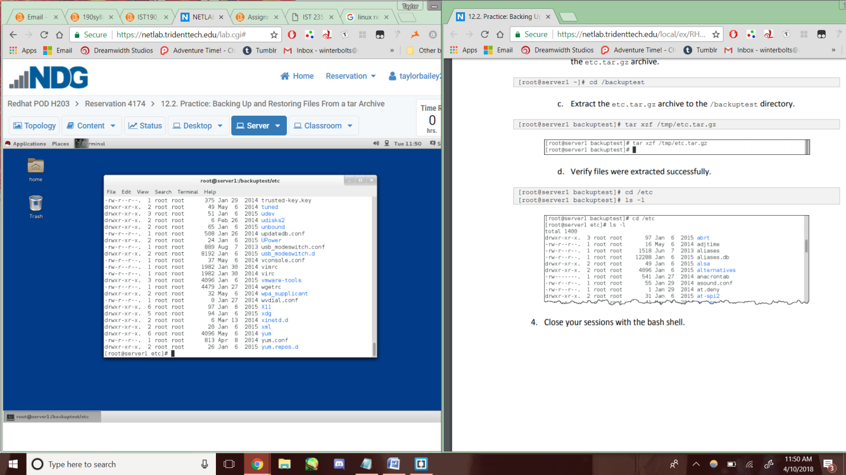

Lab6-12.4-1b

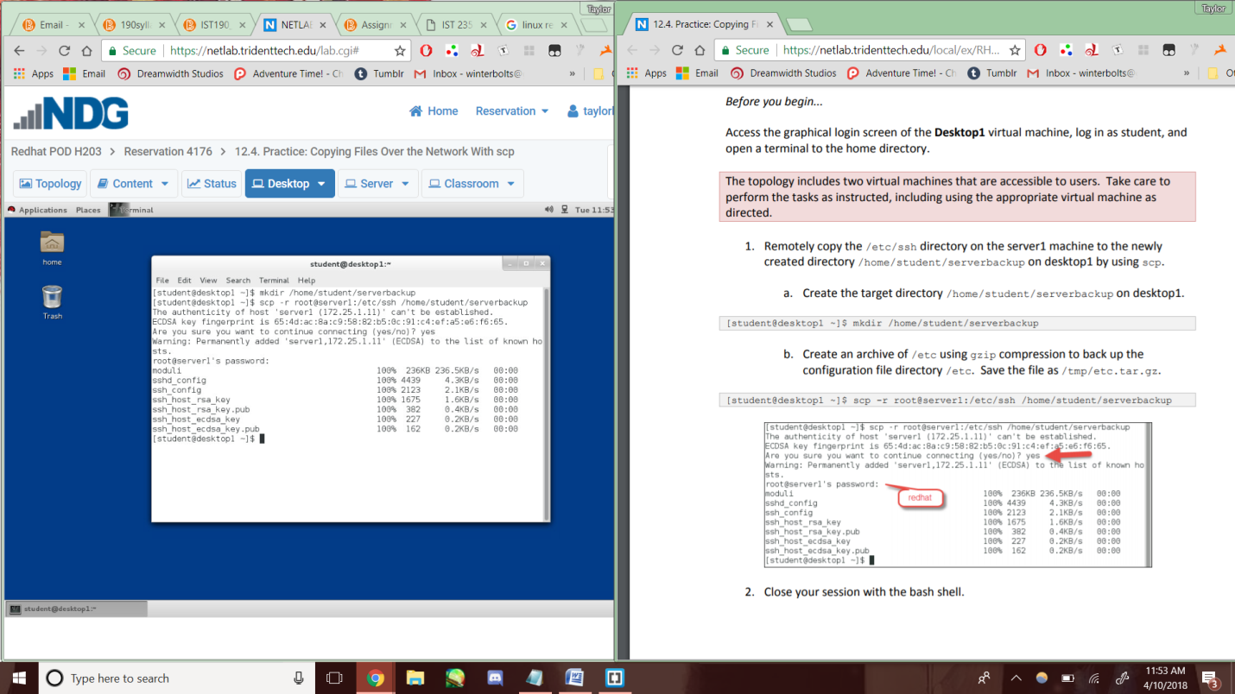

Lab6-12.6-3

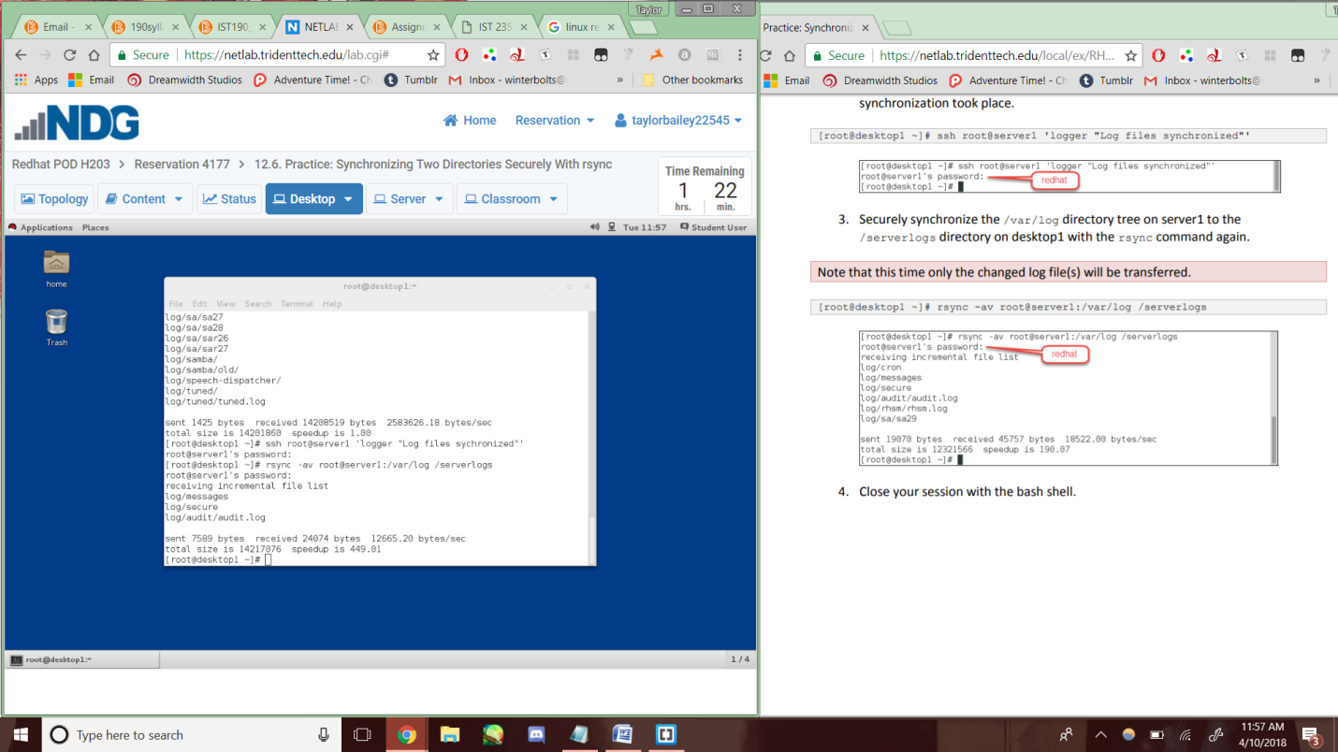

Lab6-12.7-3d

